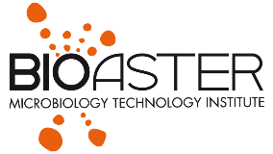

2nd IABS - BIOASTER Webinar
International Alliance for Biological Standardization

Standards for Faecal Microbiota Transplant:
Tools and Therapeutic Advances

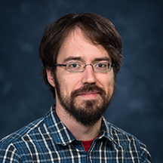

Benjamin Callahan

Associate Professor

27606 Raleigh, NC, USA

North Carolina State University

Address: 1060 William Moore Drive

Tel: + 1 (919) 515-8536

Fax: +

E-mail: benjamin.j.callahan@gmail.com

The advent of high-throughput biological assays and the “big data” they produce has revolutionized biological inquiry. But measurements made without a deep understanding of their limits and biases contribute more noise than signal to the scientific process.
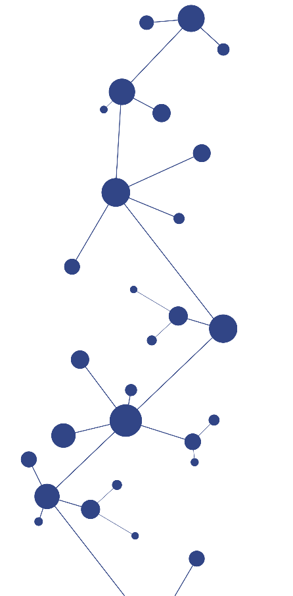
In the Callahan lab we are working to improve the characterization of microbial communities by modeling and correcting errors and artefacts in our measurement methods. We are developing new biomarkers of disease by carefully combining clinical outcomes with measurements of the human microbiome. And we are trying to improve our understanding of the microbiome in health and disease by integrating data from multiple studies in a way that accounts for differences in the underlying measurement methods.

