2nd IABS - BIOASTER Webinar
International Alliance for Biological Standardization

Standards for Faecal Microbiota Transplant:
Tools and Therapeutic Advances

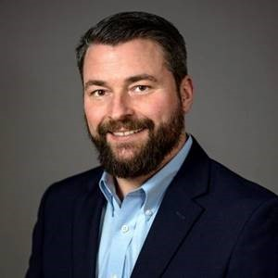

Scott A. Jackson
Leader – Complex Microbial Systems Group
NIST - National Institute of Standards and Technology
Gaithersburg, MD, USA 20899

Tel: (240) 620-7321

E-mail: scott.jackson@nist.gov

Scott Jackson joined The National Institute of Standards and Technology (NIST) in May of 2014. At NIST, Scott is currently the leader of the Complex Microbial Systems Group in the Biosystems and Biomaterials Division. In this current role, Scott is leading international efforts to improve microbiome and metagenomic measurements by organizing inter-lab studies, developing reference materials and reference methods, and developing in vitro tools that allow us to better understand microbial community resilience and evolution.
Prior to joining NIST in 2014, Scott spent 11 years as a principal investigator with the FDA. At FDA, his research focused on characterizing the global genomic diversity of enteric pathogens, with applications for food safety, bioforensics and public health.
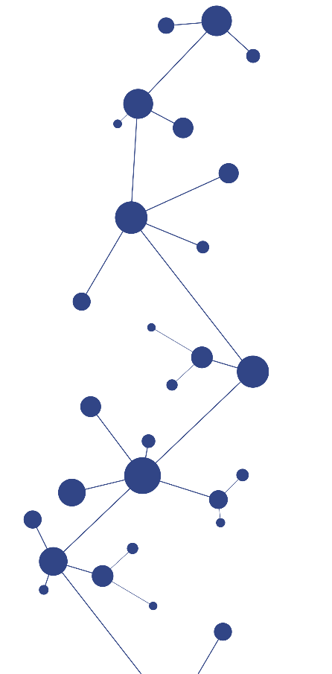
Scott performed his PhD research in biochemistry and biophysics at The University of Maryland and Johns Hopkins University, respectfully, where he focused on the evolution of mobile genetic elements using yeast as a model genetic organism. Scott performed his undergraduate studies in Chemistry and Geology at the University of South Carolina.

