

2nd IABS - BIOASTER Webinar
International Alliance for Biological Standardization

Standards for Faecal Microbiota Transplant:
Tools and Therapeutic Advances



Paul E. Carlson, Jr. Ph.D.

Principal Investigator

U.S. FDA/CBER

Address: 10903 New Hampshire Ave. Silver Spring, MD, 20993 USA

Tel: +1 240-402-4090

Fax: +

E-mail: paul.carlson@fda.hhs.gov

Paul Carlson, Ph. D., is a principal investigator in the Laboratory of Mucosal Pathogens and Cellular Immunology, Division of Bacterial, Parasitic, and Allergenic Products, Office of Vaccines Research and Review, CBER, FDA. Dr. Carlson received his PhD from the University of Pittsburgh; he performed postdoctoral research at the University of Michigan in the laboratory of Dr. Phil Hanna. His research at FDA has focused on infections caused by the enteric pathogens Clostridium difficile and Vancomycin resistant Enterococcus (VRE) species, specifically, 1) mechanisms of C. difficile pathogenesis; 2) development of genetic tools to study C. difficile; 3) host response to C. difficile; 4) the role of the host microbiota in C. difficile colonization resistance; 5) bacteriophage therapy against VRE.
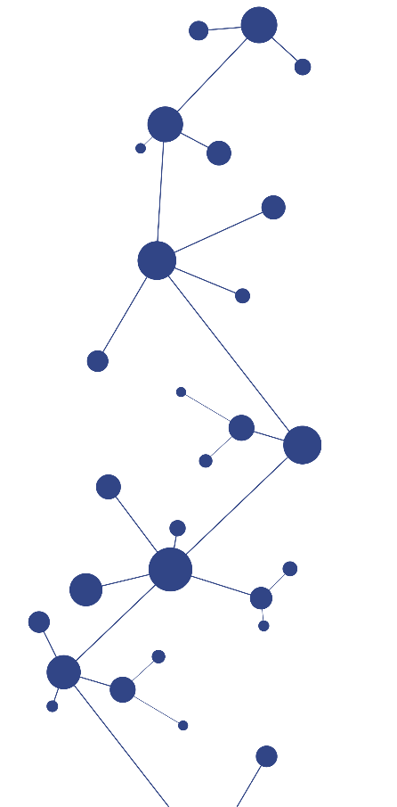
Dr. Carlson is a member, and former chair, of the FDA microbiome working group, the Joint Agency Microbiome (JAM) working group, and was a member of the Microbiome Interagency Working Group (MIWG). His regulatory responsibilities include product (Chemistry, Manufacturing, and Control) review for fecal microbiota transplantation (FMT) products, defined live biotherapeutic products, and bacteriophage therapies.

