

2nd IABS - BIOASTER Webinar
International Alliance for Biological Standardization

Standards for Faecal Microbiota Transplant:
Tools and Therapeutic Advances

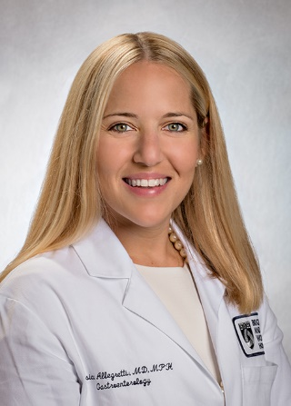

Jessica R. Allegretti, M.D., M.P.H, FACG

Director, Fecal Microbiota Transplant Program
Brigham and Women’s Hospital
Harvard Medical School
Boston, MA 02140

Tel: 1+ 617-732-6389

Fax: 1+ 617-732-9198

E-mail: jallegretti@bwh.harvard.edu

Dr. Jessica Allegretti is a gastroenterologist and physician-scientist dedicated to discovering and developing innovative microbiome therapeutics and novel treatments for inflammatory bowel disease. She currently serves as the Associate Director of the Crohn’s and Colitis Center at Brigham and Women’s Hospital, where she built and leads the Clinical Trials Program. She also founded the hospital’s Fecal Microbiota Transplantation Program and continues to serve as the Program’s Director. She also serves as the Director of Clinical Research for the Division of Gastroenterology.



