
International Alliance for Biological Standardization

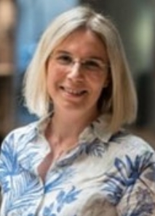

Valeria Maria Zanda

Head of Innovative Sequencing & Data Science Lab

10010, Colleretto Giacosa, Italy
Merck
Address: via Ribes, 1

E-mail: valeria.zanda@merckgroup.com

Valeria Maria Zanda, PhD, is the head of Innovative Sequencing & Data Science Lab within the Healthcare business of Merck. In her role, she is involved in the development and validation of innovative molecular methods based on sequencing technologies.
She holds a Master Degree in Biotechnology from the University of Milano-Bicocca and a PhD in Industrial Biotechnologies. She has been part of Merck since 2008, first within the R&D organization, then moved to Quality Control, where she has supported the implementation of molecular technologies for several applications. In particular, since 2011 she has been a subject matter expert working on the implementation of NGS technologies, leading or contributing to several efforts in method development in both viral safety and genetic characterization.

