Enabling the Evaluation of COVID-19 Vaccines with Correlates of Protection
Vaccinopolis
University of Antwerp, Belgium
February 16 - 17, 2023



Dean Smith, Ph.D.

Tel: +1 613-799-5689

E-mail: dean.smith@hc-sc.gc.ca

Immunologist and A/Manager of a Vaccine Quality Division and Advisor in the Center for Vaccines, Clinical Trials and Biostatistics at Health Canada. Dr. Smith has over 20-years of experience in regulatory science in support of innovation in vaccine development, manufacturing and quality control. He has a wide range of biologics-based scientific and regulatory experience from his Senior Scientific Evaluator and management roles in Centre Divisions including Viral and Bacterial Vaccines, as well Hemostatic Agents and Blood Substitutes.

Representing Health Canada, Dr. Smith contributes to WHO’s vaccine and vaccine stability guidance development initiatives and supports WHO’s recent efforts with COVID-19 and Monkeypox vaccine responses. He is Health Canada’s representative to the European Directorate of Quality of Medicines (EDQM), Group 15 (Vaccines and Sera) in support of the European Pharmacopeia, the Regulatory Advisory Committee to the WHO/Collation for Emergency Preparedness and Innovation (CEPI) and served on the Science and Ethics Advisory Committee for VAC2VAC under the European Vaccines Initiative.

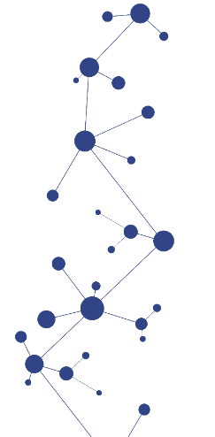
Dr. Smith's Ph.D. in Immunology is from the University of Alberta, Canada, where his research dealt with vaccine antigen discovery, autoimmunity and viral vector-based gene therapy. He was a Research Associate at the National Research Council’s Institute of Biological Science, Vaccine Design Group in Ottawa prior to joining Health Canada.
IABS | Correlates of Protection – February 16-17, 2023

